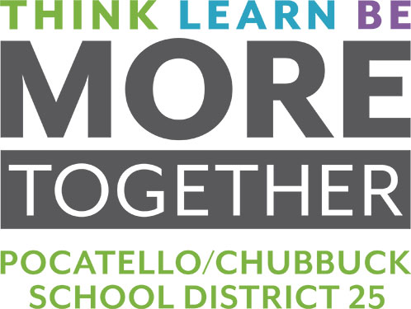
ABOUT THE BOARD OF TRUSTEES
Recent Board Accomplishments
FOSTERING ACADEMIC ACHIEVEMENT and COLLEGE & CAREER READINESS
- Graduated 91.1% of learners in 2020, well above Idaho’s 82% state average. Graduated 100 Class of 2020 learner from New Horizon High School.
- Outperformed state averages for ISAT scores in English language arts, math and science for all grades tested.
- Created and sustained 25 Career Technical Education pathways for post-secondary careers, including 125 courses with opportunity for corresponding college credit.
- Grew participation in Advanced Opportunities. PCSD 25 high school learners have earned more than 40,000 college credits since 2015, equivalent to $13M in out-of-pocket tuition value at ISU.
- Recognized graduates for earning nearly $27M in scholarships offered in 2019.
Added STEM designation to honor qualifying graduates on their transcripts and diplomas. Learners receiving this recognition also receive STEM chords to wear at graduation.
PRIORITIZING EQUITY IN EDUCATION
- Delivered continuity of learning with a robust action plan that addresses the challenges of providing educational services in the midst of a pandemic.
- Established new enrollment boundaries in 2018 to balance future enrollment at all 3 high schools, positioning each for fair, equitable growth.
- Pioneered collaborative community resource partnerships to meet the needs of high-risk youth and their families. PCSD 25 is the only district in the state to integrate a model supporting the Juvenile Detention Center (JDC) and Youth Development Center (YDC).
- Established other in-school support systems include Community Resource Workers; behavior coaches; mental health counselors; restorative practices; school resource officers/partnership with the Pocatello Police Department; and the Crossover Youth Program model, a partnership between PCSD 25 schools, juvenile probation and Health and Welfare.
- Retired the Pocatello High School Indian Mascot in response to a position paper submitted by the Shoshone-Bannock Business Council to the Governor and the State Board of Education requesting the retirement of Native American themes and imagery across all Idaho public schools.
STEWARDING FISCAL RESPONSIBILITY
- Retired the long-term bond and debt for Century High School in 2016, earlier than scheduled.
- Maintained the Supplemental Levy amount for 6 consecutive years.
- Continued the district’s longstanding commitment to well-maintained schools and district facilities through the advancement of the Capital Improvement Plan’s 5-year replacement schedule.
- Earned a Certificate of Achievement of Excellence in financial reporting for 30 consecutive years, the only district in the state to earn a designation in financial transparency from both GFOA and ASBO.
MOBILIZING INSTRUCTIONAL TECHNOLOGY
- Launched 1:1 Chromebook Initiative with the distribution of 12,500 devices, one to every PCSD 25 learner for use in both in-person and remote learning. This action positioned the school district to be responsive to an ever-changing educational landscape, including the District’s response to the coronavirus pandemic. This action also increased equity of access to education for every learner.
- Directed federal CARES Act funding toward the allocation of next generation instructional technology designed to improve teaching and learning.
ADVANCING FORWARD-THINKING FACILITIES
- Completed projects including, the construction of New Horizon High School and Iron Horse Stadium; the renovation and reopening of Alameda Middle School; the improvement of parking lot and bus lanes to address safety concerns; and the addition of elevators at various sites to enhance ADA accessibility; among many others.
- Completed phase I of the Pocatello High School improvement project and initiated phase II, which is projected to be completed by the beginning of the 2021/2022 school year.
- Approved a 5-year outdoor athletic facilities improvement plan. The first phase of the plan will be initiated in Summer 2021.
EARNING RECOGNITION FOR BOARDSMANSHIP
- Recognized by the Idaho School Boards Association through its annual Award of Leadership for exemplary service, most recently in 2018, 2019 and 2020.

Each accomplishment is aligned with the PCSD 25 Board of Trustees’ Operating Principles and
Code of Ethics. Learn more at sd25.us.

